Astroshelf__

User's Manual

Startup:
To run Astroshelf, please see the document entitled "To Run Do This."

When Astroshelf is running, you will be greeted by a black screen with a grid drawn on it. This Grid represents Right Ascension and Declination coordinates. At the top of the screen is a list of overlay queries (You start with just one, but you can add more). The bottom of the screen indicates the Right Ascension and Declination of the cursor.

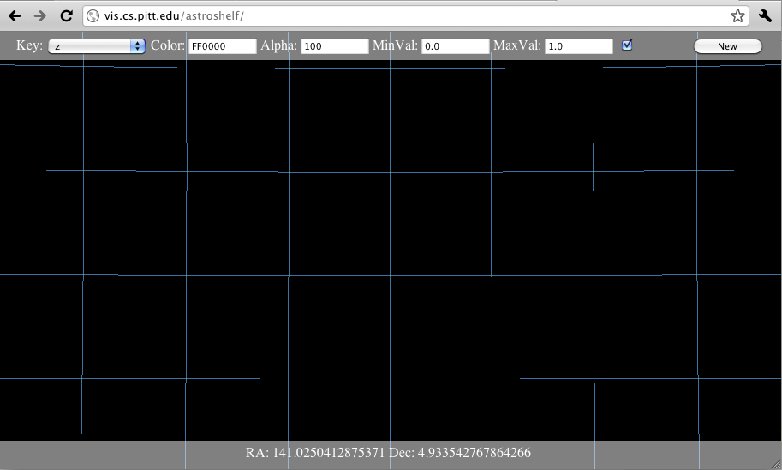

Controls:
In order to change your viewing area, click and drag the middle of the screen.

In order to zoom in, press the 'q' key.
To zoom out, press the 'a' key. (Note that the zoom controls are likely to change)

To toggle whether or not the Grid is displayed, press the 'g' key.

Queries:
Queries will cover a bounding box of the viewable area onscreen. The overlays will update automatically when a query is changed.

1. Loading Indicator - will display whenever the overlay is updated
2. Key Parameter - This object parameter will be mapped to the alpha channel of the overlay
3. Color - Base color of the overlay, this must be a 6 digit hexadecimal value
4. Alpha - Base opacity of the overlay, this is a percentage between 0 and 100
5. MinVal - The minimum value of the Key Parameter. Any data point with the Key Parameter at or below this value will be transparent in the overlay.
6. MaxVal - The maximum value of the Key Parameter. Any data point with the Key Parameter at or above this value will be opaque in the overlay.
7. Visible Checkbox - If checked this overlay will be drawn, otherwise it will be invisible
8. New Overlay Button - when clicked, this will add an additional, configurable overlay to the interface. *

* Currently there is no way (other than a hard 'refresh') to remove an overlay once it has been added.

